41st ANNUAL RPCA ANNIVERSARY DINNER
Come and join us for our Annual Anniversary Dinner at Cooper’s Hawk Winery & Restaurant located at 11792 W. Broad Street in Henrico. This event is designed to be a time of food and fellowship and a special occasion that you can enjoy with your spouse, special friends and star employees. The cost is $70.00 per person.

When: Tuesday, April 4, 2023 at 6:00pm
There will be a cash bar and dinner will be served at 6:00pm.

4 Course Meal Will Include Your Choice of the Following:
- Crab, Shrimp & Lobster Bisque
- House Salad
- Duo Filet Medallions (beef)
- Cooper’s Hawk Chicken Giardiniera
- Assorted Desert Platter

Please register online at www.pdcarva.org
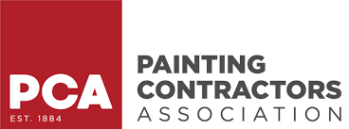
We look forward to seeing you there!

